How to Import a Roster, Print Camera Cards, and Match Data using Lab Link.

I. Preparing Roster for Importing

Obtain the roster from the school.

In external software, review the spreadsheet and make any necessary changes to accommodate how you may photograph the subjects. You may want to sort the roster by certain data or add certain columns such as school name.

You may want to print extra blank camera cards (you will need to do this if you plan to auto match the data to the images.) The easiest way to do this is add more rows with the school name field beyond your last subject. Example:

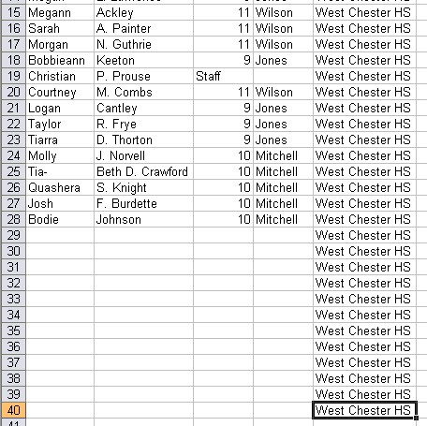

If you plan to auto match the data and images you will want to use one of these blank cards as your “slate shot”.

Before saving and closing the spreadsheet, make sure you have column header names. For example: Firstname, Lastname, Teacher, Grade, Schoolname, StudentID.

You do not need to worry about creating a generic SubjectID column as Lab Link will do this for you. If you must use one that is supplied to you, it is necessary that it be all numeric. However, it is recommended that Lab Link generate the SubjectID whenever possible.

Finally save your roster with the extension of .csv (Comma Delimited). You may want to choose file type .txt (Tab Delimited) if your roster contains any commas.

II. Importing a Roster into Lab Link

Open Lab Link and create a new job. After typing job name press Done.

Click on the Modify Data button at the bottom of the screen. Click Import Roster on the next two windows until you are able to browse for you roster file.

Once the file is located click open and the column names from your roster should appear on the left side of the Import Roster Window while Lab Link’s database columns will appear on the right side. This is where you tell Lab Link where the data from the roster should go.

Choose any field from the left side and find the field that corresponds to it on the right side. For example, First Name and FirstName, or Student ID Number and StudentID. With the two corresponding fields highlighted, click the Map button. This will throw both to the bottom of the window to show that the data in the Student ID Number field will import into the StudentID field in Lab Link. If you match two incorrectly, simply highlight them at the bottom of the screen and click Unmap. Example:

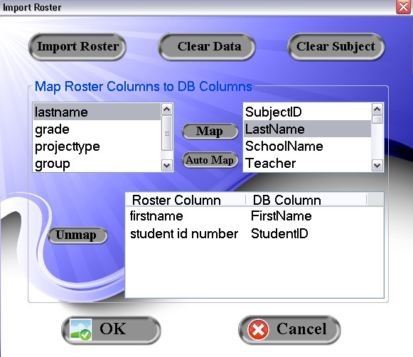

If you are confident with your roster’s column names matching Lab Link’s database names use the Auto Map button to align the two together. You can always start with this method and then manually map the fields that Lab Link was unable to match together. If Lab Link matches two incorrectly, highlight them and click Unmap. You will then need to manually map these.

Once all of the fields on the left side are moved to the bottom of the window click OK.

The Import Preview Form will open and show you where the data will be imported in Lab Link. You will also see the SubjectID field that Lab Link automatically generates if you do not have one.

If the data appears to be incorrect in this form click Cancel and remap the roster fields with Lab Link’s database fields. You may want to click the Clear Data button at the top right of the window just to be sure no incorrect data is saved before doing the remapping.

Repeat the steps until you are happy with the way the data looks in the Import Preview Form. Click OK.

You are now ready to print camera cards. Click Done on the Import Data Options window to return to the main Lab Link screen. If you are not printing camera cards skip to step IV and import your images.

III. Printing Camera Cards

From the main Lab Link screen highlight your job and click the Reports button. A window will open where you can choose from a variety of reports. Choose the Camera Cards report and click OK.

When the preview opens click the print layout button located beside the printer icon to preview how the cards will print. The cards are designed to work with 8-Up 8.5”x11” sheets from Think, Inc.

Print your cards.

(This is when you would be photographing.)

At this point reference the ImageLink help document if assistance is needed with your barcode scanner upload.

IV. Import your images

Once you have shot your images you will need to import them in to the job. Highlight your job from the main Lab Link screen and click the Add Images button. Browse to your images or drag and drop them in to the Add Images window. If you shot with multiple cameras you can add all images at once or add and match one camera at a time see section VII. Matching with multiple cameras. Click Done.

V. Match your Images

Highlight your job from the main Lab Link screen and click Modify Data.

In the Modify Data Options window choose how you will match the data to your images.

Subject ID Order – If no additional sorting of the roster is required and you have identified who the subjects are on the camera cards or by other means.

Sort By Data Column – If you shot the subjects in a particular order and need to sort the roster in the same order for convenient matching.
Use ImageLink Upload File – If you scanned camera cards while photographing subjects and used ImageLink to create an xml data file, choose this option to import the data file for auto-matching your roster to your images.

Select the method that best describes your situation and click on Match Data.

The Match Images Form opens with your imported roster in the top left box and your imported images in the top right box. The goal is to move all images from the top right box to the lower right box by matching them with lines from the roster. All images must be moved out of the top right box before the job can be considered matched.

To match, click on a line from the roster in the top left box. Find the image that corresponds to the line that is selected, highlight it, and click the Match button. The line from the roster drops from the top left box to the lower left box and the image from the top right to the lower right. This is how a job is matched in Lab Link. As you continue to match, the top boxes will have less data or images, and the lower boxes will have more.

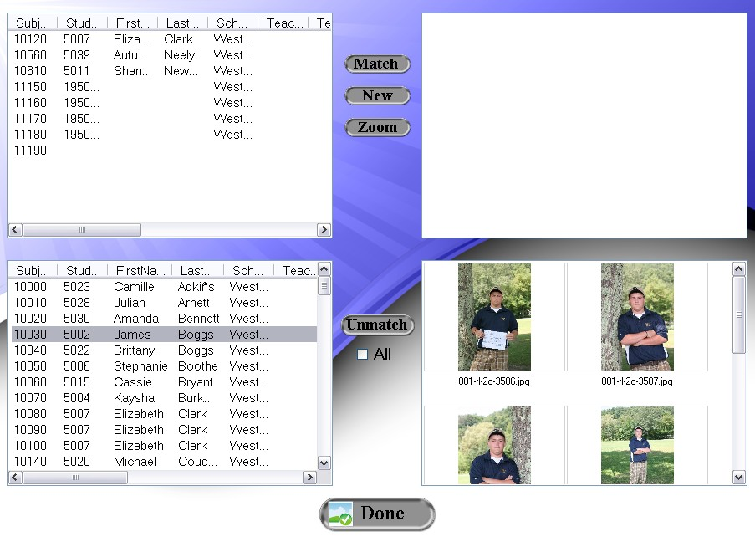

At any time you can drag and drop images back and forth between the upper and lower boxes. No information is saved to the image until you click Done so don’t worry about messing up your data or images.

Any leftover data in the top left box is ok. These are the extra blank cards you may have created or any kids that were absent on picture day. You cannot have leftover images in the top right box or you will be unable to enter Lab Link’s Build Job mode.

If someone was shot but you do not have a row of data for them, click the New button to create a SubjectID. In this window you can enter the subject’s information. After clicking OK, the row will appear at the bottom of the roster in the top left box. Match to the image(s) as described earlier.

For the subjects that are matched with a blank camera card roster line, their information can be input in Build Job mode once all images are matched.

When the top right box is empty, the job is matched and can now be opened with the main screen’s Build Job button for package creation and cropping.

VI. Matching with Use ImageLink Upload File

Select the Use ImageLink Upload File option and click Match Data. Browse to your CameraBarCodes.xml file and click Open. This will open the roster and images in the order in which they were scanned and shot.

If you shot a “slate shot” and scanned your “slate card” and wish to auto match your data and images, select the slate shot image in the top right box and click Auto. Choose the amount of time that elapsed between scanning your “slate card” and shooting your “slate shot”. This should ideally be 1 to 2 seconds. Click OK.

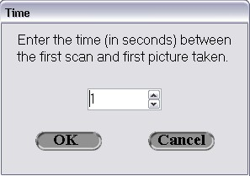

Your roster and images should move from the top boxes to the lower boxes. Click or use the arrow keys to navigate through the roster in the lower left box. Watch the images in the lower right box to verify that they match with the names you are clicking.

If a card was not scanned before a new subject was taken, different subjects will be grouped together. Drag and drop the incorrect subject from the lower box to the top box. This person will either need to be matched using the New button for SubjectID creation, or by matching through SubjectID Order. This should be done after verifying that all other matching is correct. Once verified, click Done on the Match Images Form. Now select SubjectID Order and click Match Data. Find the subjects name from the roster in the top left box and highlight their image. Click Match.

If the data and images seem totally incorrect after the initial auto match, check the All box and click the Unmatch button.

When the images and data have “unmatched”, click on your slate shot again and try auto-matching with a different time. Verify the data and images match and that no images are left in the top right box and click Done.

If the “slate card” and “slate shot” method were not done, the job must be manually matched. The roster and images will be in the correct order with each other so matching should be very simple. Highlight the first line from your roster (which is also the first card scanned) and select the image(s) after your first scan. Click Match. Continue until all images have been moved from the top box to the lower box. Verify no errors have been made and click Done.

If you also scanned a package barcode, you will want to click Yes to add the package to the images. Keep in mind that this adds the package to all images if multiple poses were shot. The extra poses will need to be deleted in the Build Job screen.

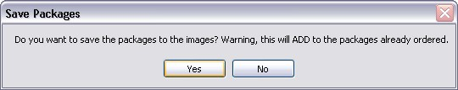

Click No if you will add package information later.

The job can now be opened with the main screen’s Build Job button for package creation and cropping.

VII. Matching with multiple cameras

If multiple cameras were used for a shoot with the intent of auto matching make sure the correct slate shot is chosen with the selected CameraBarcodes.xml file.

It may be easier to add the images from one camera and match them with the data before adding the images from another camera and matching them. Just add the images from one camera and then follow the steps outlined above in section VI. in order to get all of camera one’s images matched. Close the Match Images Form, add the second camera’s images, and again follow the steps from section VI.

All of your camera’s images can be added at the same time but you must be careful to select the correct slate shot that corresponds to the CameraBarcodes.xml file that you selected from the Modify Data Options window. Select the correct slate shot and choose auto match as outlined in section VI. After verifying that all images are matched from camera 1 select the slate shot from camera 2 and choose auto match.

Verify no errors have been made and click Done.

