How to Crop in Lab Link

I. Using the Crop Screen

When the crop screen opens you will see your images displayed down the right side. The cropping zone is at the top and your products and their crops are displayed along the bottom. Click on your first image. You should see the larger image to the left, products for that image displayed at the bottom of the screen, and the crops associated with those products to the right. For example if your image has an 8x10, 2-5x7s, 3-4x6s, and 8-wallets keyed on it you should see the crops 8x10, 5x7, and 4x6 listed. Lab Link automatically selects all the products, selects the top crop from the list (in this case the 8x10) and applies it to the image in the cropping zone for you.

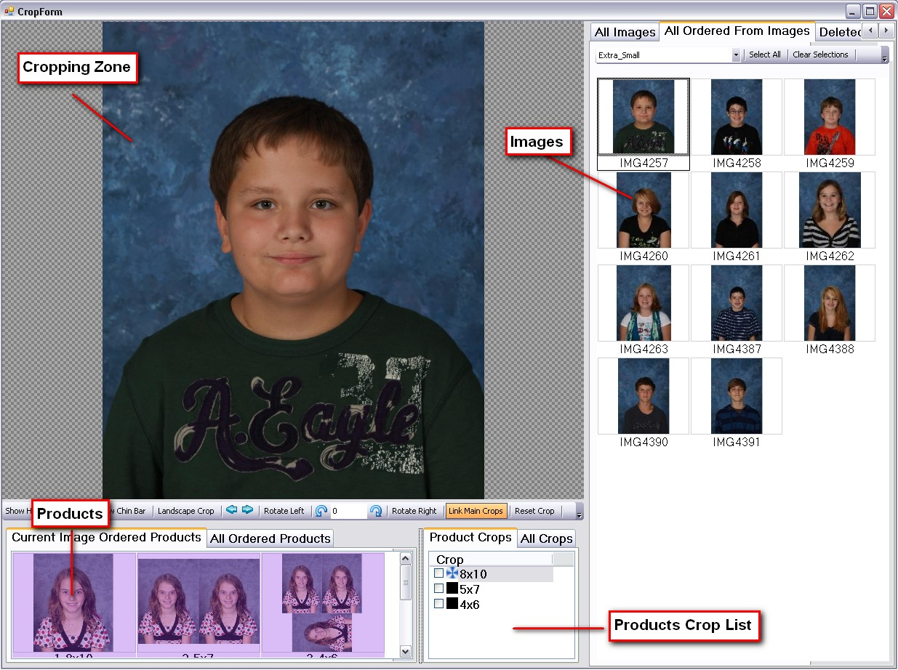

If you need to zoom in or out beyond what you see, right click and hold on the image in the crop zone and move your mouse up or down. Then left click and hold on the image to reposition. This crop preview shows approximately how the image will print based on the crop displayed. You should always preview the product in the View Order Screen to make sure the product looks as you intended (refer to the View Order Screen help document for additional info).

Once you are happy with this particular crop click on the next crop (for our example the 5x7) in the Crop List (shortcut key is ‘m’ to move through the crops). The 5x7 by default is set to copy the 8x10 crop, so you should just see the image lose a little from the sides. You can zoom in or out on this crop if you want it to be different from the 8x10 crop. When you are happy with it hit the ‘m’ key or click on the next crop in the list (now the 4x6) and crop it. Once all crops have been made you can click through the crops to view each one and compare them. At any point you can re-crop. If you want to see which crop goes with which product just click in an empty area of the products window to de-select all and then click a specific product. If you select an 8x10 only the 8x10 crop should show in the Crop List. You will need to click on the 8x10 crop at this point to crop for the 8x10. If you click in the empty area of the Crop List to de-select the crop you should see your original image displayed. Click back on the 8x10 crop to see the image with the crop. The shortcut key for this is ‘b’ and can be done at any time during cropping. Now click on a different product like the 4x6 and you should see only the 4x6 crop displayed.

Keep in mind that one product could have more than one crop and that multiple products could share the same crop.

For example a sheet of 1-5x7 and 2-4x5s will have an 8x10 crop and a 5x7 crop. Also a sheet of 2-5x7s and a sheet of 4-3x5s will both share the 5x7 crop. Also there is the potential for basic sheets to share crops with other products like groupmates or trader cards or mousepads. We have put a lot of effort in to creating a streamlined system for keying packages and quickly cropping images while allowing for maximum flexibility, but there is some limitation. If you have a situation where you need a very specific crop for a product but it shares that crop with another product, you should key that product through MP Mode where you are able to crop separate from the Crop Screen. Refer to the MP Mode document for additional info.

Once all the crops for your selected image are satisfactory, click on the next image from the right and repeat the steps. Once again Lab Link will automatically select all products and display the top crop from the list.

II. Additional Buttons and Tips

Shortcut keys- ‘b’- toggle between cropped and uncropped preview
‘n’ - go to the next image
‘m’ - move through the crop list
‘p’ - previous image

Button Toolbar

*Show Head Height Bar - Puts a guide bar for the top of the head. The bar can be repositioned by clicking and dragging it.
*Show Chin Bar - Puts a guide bar for the chin. It too can be repositioned.
*Landscape Crop - Converts the crop to horizontal. Gives you the ability to take a vertical image and print it horizontally. Also horizontal images by default will use this button. Turn off to crop a horizontal image vertically.
*Arrows - To move to the next and previous images
*Curved Arrows - Use these to change the angle of the image. Shift-Click the arrow to see a bigger change. Also you can type in the box. You will need to zoom in on the image if the angle is changed.
*Rotate Left and Right - To rotate just the current image left or right. To rotate more than one image you will need to select those images on the right side of the screen, right click on one of them, and choose rotate left or right from the menu.
*Link Main Crops - On by default so the 5x7 crop will copy the 8x10.
*Reset Crop - Removes any zooming or repositioning that is done to the image after the initial crop. Double click the image in the crop zone to reset it as well.
*Delete Crop - Totally removes the crop from the product.
*Close - Closes the crop screen
*High Quality - Displays a high quality preview of the cropped image.

The rotation and angle of the image can also be altered by moving the cursor over certain places of the image in the cropping zone. Move to the left and right of the image to click and rotate it and to the top and bottom of the image to click and drag to change the angle. Double click the top or bottom of the image to reset the angle.

To apply a crop or crops to multiple images first crop the image and put a check in the box beside the crop(s) you wish to apply.

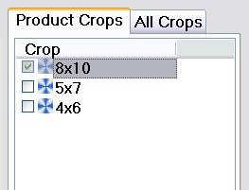

Next select the images you want to apply the crop to. Be sure to right-click on the image with the checked crop and choose Apply Checked Crops to Selected.

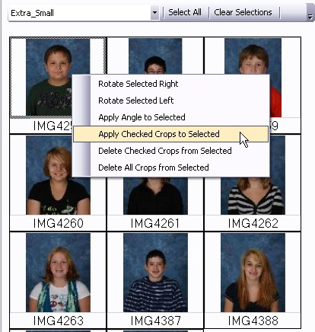

Proceed to adjust crops further as needed.

Some products in Lab Link will display a mask over the image when cropping. This is designed to give information about the crop or serve as a guide for cropping certain products. One example would be a button. A circular mask is placed over the image to simulate the shape of the button.

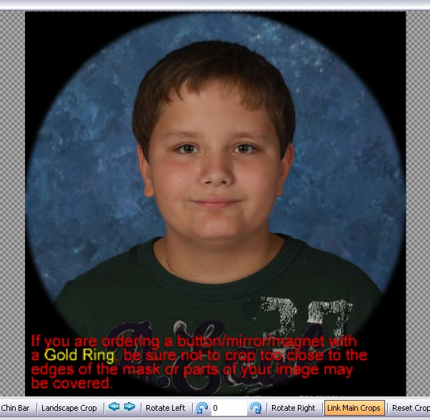

All crops save as you go in Lab Link. When cropping is finished click the X in the top right corner or click the close button from the Button Toolbar.

